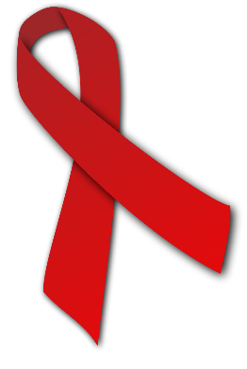
October 26– 30, 2020
2020 Red Ribbon Week

Be Happy. Be Brave. Be Drug Free
We Pledge to grow up SAFE, HEALTHY and DRUG FREE by:
1. Understanding the dangers of drug use and abuse.
2. Respecting myself and being drug free.
3. Spreading the word to family and friends about the importance of being healthy and drug free.
Red Ribbon Special Week Schedule

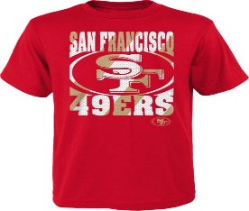

Monday: Team Up against drugs and alcohol by repping your favorite team.
(Everyone Wear your favorite team shirt or jersey on Monday)

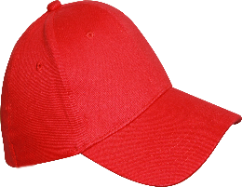

Tuesday: Let’s put a Cap On against drugs and alcohol.
(Everyone Wear your favorite cap on Tuesday)

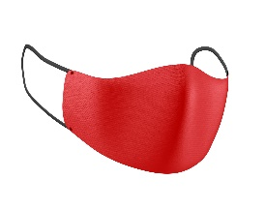
Wednesday: Mask Up to keep drugs and alcohol away from you.
(Everyone Wear your favorite mask on Wednesday)

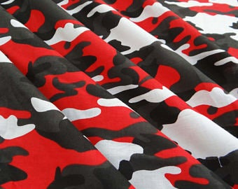
Thursday: We will go to WAR against drugs and alcohol.
(Everyone Wear your favorite camouflage shirt or pants on Thursday)

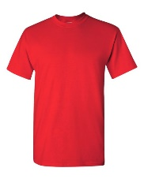

Friday: Be RED-dy to fight against drugs and alcohol.
(Everyone Wear RED on Friday)

